ENISA celebrates Safer Internet Day

Today the EU Agency for Cybersecurity, ENISA celebrates Safer Internet Day. The Agency has been an active supporter of Safer Internet Day for over nine years, and has launched several studies related to the subject matter, on privacy and security in personal data clouds and cyber hygiene practices.

Published on February 05, 2019

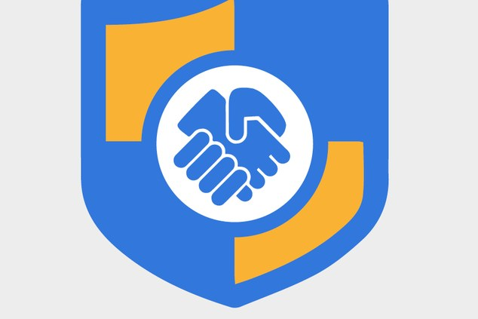

Tagged with

* [Cybersecurity Education](https://www.enisa.europa.eu/search?Subject%3Alist=Cybersecurity%20Education)
* [Network and Information Security Awareness](https://www.enisa.europa.eu/search?Subject%3Alist=Network%20and%20Information%20Security%20Awareness)
* [Online Safety](https://www.enisa.europa.eu/search?Subject%3Alist=Online%20Safety)

ENISA has also played a key role in the EU's Cybersecurity Strategy to increase people's awareness of the key role they can play in ensuring the security of networks and information systems, notably by its active involvement in the [European Cyber Security Month](https://cybersecuritymonth.eu/). ENISA has created video clips, posters and illustrations, which aim at raising information security awareness, risks, and good practices.  You can find them [here](https://cybersecuritymonth.eu/press-campaign-toolbox/infographics).

Just like the physical world, the Internet poses online threats to people, especially children and young adults physically, emotionally and financially. That is why it is of utmost importance to build cybersecurity skills and competences, which aim at raising information security awareness and helping citizens adopt good practices.

Nurturing cybersecurity skills helps individuals to defend themselves on the Internet, enabling them to become more resilient, self-reliant and confident. People with cybersecurity skills can have a positive impact on protecting those around them, contributing essentially to a safer online environment.

Are you a role model, parent, teacher, guardian or community leader? Educate children and young people by taking our [educational modules.](https://cybersecuritymonth.eu/get-cyber-skilled/education-modules)